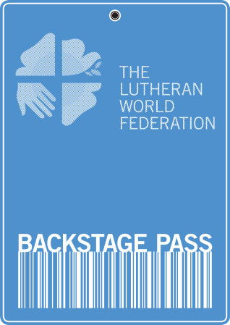
application form

LWF Backstage Pass – Nepal

25 October – 7 November 2014

Please read carefully the terms and conditions.

personal details

Title …….First Name Last Name
Personal Address …

Country

Email address
Mobile Phone number
Date of Birth

event costs (Please mark X)
I will cover my own travel costs to and from Kathmandu. Yes No
I will pay for my own food and accommodation costs
during the trip (See further information on website). Yes No
I commit to raising 1,100 Euros (1,500 US dollars) which will be
donated towards the work of the LWF in Nepal. . Yes No

visa and passport (Please mark X)

Are you eligible for a tourist visa for Nepal? Yes No
Do you hold a valid passport? Yes No

insurance details (Please mark X)
I understand that I need to organize my own travel insurance. Yes No
I will send details of my insurance to the LWF in advance of the trip. Yes No

health (See also the Information Sheet)
Do you consider yourself physically fit to walk 6 – 7 hours a day? Yes No
Do require any regular medication? (if YES, please give details) Yes No
Details of medication

meals / special needs
Do you have any special dietary requirements?
(if YES, please give details) Yes No
Within available possibilities, efforts will be made to respond to special requests; however no guarantee can be given
Special meal requirements
Food allergies
Any other special needs

declaration

By signing below, I confirm that I am over 18 yrs and have read and agree with the Terms and Conditions of this event.

Signature Date

church endorsement
I am pleased to endorse ……………………………… (Applicant’s Name) who is applying for a place on the LWF Backstage Pass. (S)he is an active member of our church.

If necessary, we will support their fundraising efforts
in order for them to participate.

Yes No

Title ……...First Name Last Name
Position …
Name of Church …
Church Address …

Email address
Church website address (if applicable)

Signature Date

Please return this completed application form before 30 June 2014 to:

Mr David Cooke
The Lutheran World Federation
150 Route de Ferney
Po Box 2100
CH-1211 Geneva 2
Switzerland
Tel: +41 22 791 6626; Fax: +41 791 6626
E-mail: dco@lutheranworld.org

For Official Use by the LWF

Date Received by LWF ……………………………… Ref No. …………………………..

