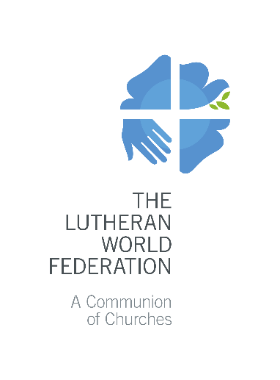
The Lutheran World Federation
P.O. Box 2100
CH-1211 Geneva 2
Switzerland
action.justice@lutheranworld.org

Application for LWF Youth Peace Projects
2021
Please fill in grey fields only. Use the Tab button to move to the next field.
Max. 3 pages. Only complete applications will be accepted.

- Summary of basic information
Name of the Project:
Applicant(s):
Contact Person:
 |  | First name |  | Last name
 |  | Email | Telephone |  | Skype
Name of Endorsing Church(es):
Total Amount Requested to the LWF for the entire project: |  | EUR: (maximum 2,000 EUR for 2021)
Have you applied for any other LWF specific grants? If yes, please provide details:
- Project background and purpose

Explain the specific peace and conflict impact-related problems and needs which the project aims to address. Summarize what the project aims to achieve. Provide information about its geographical location.

- Target group

Describe the target group/beneficiaries. Be specific, provide numbers and disaggregate by age and gender, if possible.
- Project Objectives and Activities

Describe in concrete terms what the project intends to achieve within its implementation period (max. 2 objectives). For each objective, describe the main (max. 2) activities contributing to its achievement.

Project goal (Long-term objective to which the project makes a contribution)

Objectives  Be S.M.A.R.T., bring the subject of change to the front, set clear targets and time frames | Activities:  For each activity, define its duration, recurrence, the number of beneficiaries, be specific
Objective 1) | Activity 1.1  Activity 1.2
Objective 2) | Activity 2.1  Activity 2.2

- Project coordination and implementation

Describe Youth participation, who will coordinate the project and who will be involved in its implementation.
- Financial plan and budget

You can use this space to provide more details about the budget of the project.

List of attachments | - Annex 1 - LWF- Youth Peace Project budget format 2021  - Endorsement letter by LWF Member Church

Specific, Measurable, Achievable, Realistic and Timebound
Example: “X” members of a specific community participated in activities promoting action for peace.
Example: Organize one day awareness raising trainings for 35 young people on how to engage in advocacy for peace.

