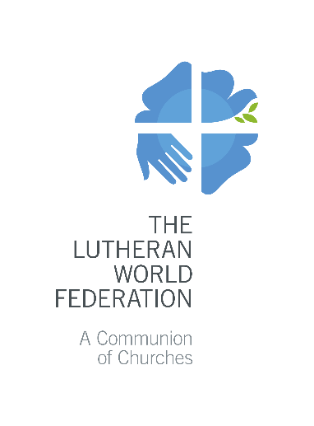
The Lutheran World Federation
P.O. Box 2100
CH-1211 Geneva 2
Switzerland
rrfprojects@lutheranworld.org

COVID-19 Rapid Response Fund
Application for LWF Member Church Project 2020
Please fill in grey fields only. Use the Tab button to move to the next field.
Max. 3 pages. Only complete applications will be accepted.

- Summary of basic information
Name of the Project:
Applying Church(es)/Institution(s):
Contact Person:
 |  | First name |  | Last name
 |  | Email | Telephone |  | Skype
Name of Endorsing Church(es):
Total Amount Requested to the LWF for the entire project: |  | EUR: (maximum 5,000 EUR for 2020)
Have you applied for any other COVID-19 specific grants? If yes, please provide details:
- Project background and purpose

Explain the specific COVID-19 related problems and needs which the project aims to address. Summarize what the project aims to achieve.
- Target group

Describe the target group/beneficiaries. Be specific, provide numbers and disaggregate by age and gender, if possible.
- Project Objectives and Activities

Describe in concrete terms what the project intends to achieve within its implementation period (max. 3 objectives). For each objective, describe the main (max. 3) activities contributing to its achievement.

Project goal (Long-term objective to which the project makes a contribution)

Objectives  Be S.M.A.R.T., bring the subject of change to the front, set clear targets and time frames | Activities:  For each activity, define its duration, recurrence, the number of beneficiaries, be specific
Objective 1) | Activity 1.1  Activity 1.2  Activity 1.3
Objective 2) | Activity 2.1  Activity 2.2  Activity 2.3
Objective 3) | Activity 3.1  Activity 3.2  Activity 3.3

- Project coordination and implementation

Describe who will coordinate the project and who will be involved in its implementation.
- Financial plan and budget

You can use this space to provide more details about the budget of the project.

List of attachments | - Annex 1 - LWF-DTMJ COVID-19 RRF budget format 2020  - Endorsement letter by LWF Member Church

Specific, Measurable, Achievable, Realistic and Timebound
Example: 250 members of a specific community can protect themselves and their families from COVID-19
Example: Organize 3 one day awareness raising trainings for 35 people on how to prevent spreading the COVID-19 disease

