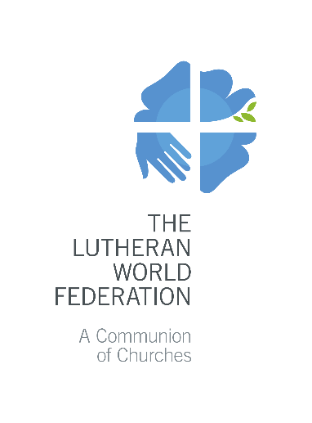
The Lutheran World Federation
P.O. Box 2100
CH-1211 Geneva 2
Switzerland
DMDprojects@lutheranworld.org

Application for LWF Member Church Project
For the period 2021-2023
Please fill in only grey fields. Use the Tab button to move to the next field.
Max 7 pages. Only complete applications will be accepted.

- Summary of basic information
Name of the Project:
Applying Church(es)/Institution(s):
Contact Person:
 | First name |  | Last name
 | Email | Telephone |  | Skype
Name of Endorsing Church(es):
Total Amount Requested to the LWF for the entire project: | EUR: (maximum 50,000 EUR per year)
Status: | New project |  | Continuation
- Project background and rationale

Explain the problems, the needs and the opportunities the project is addressing. Describe if and how women, men and young people are differently affected.

Analyze why and how the member church is called to respond to these problems and how the project links to its priorities/strategy?

In case of continuation, describe achievements to date and explain how this new phase builds on the previous phase(s) of the project.
- Impact of the project

Describe the project using simple language, focusing on its strategic approach and the significant change(s) the project aims to achieve in the church and/or the society.

Analyze if and how the project will differently affect women, men and young people.

Explain if and how the project will ensure that the positive change will last after the project has ended (sustainability).

- Logframe

Describe in concrete terms what the project intends to achieve within its implementation period (max 3 objectives). For each objective, describe the indicators (max 2 per objective) that you will use to measure the impact of the project and its main activities (max 5 per objective).

Project goal (Long-term objective to which the project makes a contribution)

Objectives  Be S.M.A.R.T., bring the subject of change to the front, set clear targets and time frames | Indicators:  Insert Indicators (plus measurable baseline and target in brackets, if applicable). Please include at least one indicator on women and/or youth participation (if applicable). | Activities:  For each activity, define its duration, recurrence, the number of beneficiaries, be specific
Objective 1) | Indicator 1.a  (baseline: , target: )  Indicator 1.b  (baseline: , target: ) | Activity 1.1  Activity 1.2  Activity 1.3  Activity 1.4  Activity 1.5
Objective 2) | Indicator 2.a  (baseline: , target: )  Indicator 2.b  (baseline: , target: ) | Activity 2.1  Activity 2.2  Activity 2.3  Activity 2.4  Activity 2.5
Objective 3) | Indicator 3.a  (baseline: , target: )  Indicator 3.b  (baseline: , target: ) | Activity 3.1  Activity 3.2  Activity 3.3  Activity 3.4  Activity 3.5

- Target group

Describe the target group/beneficiaries. How have you involved the target group, in particular women and youth, in the planning of the project?

How do you plan to involve them in its implementation and management? Be specific, provide numbers and disaggregate by age and gender.
- Project management structure and staff

Describe the management structure of the project, with a specific focus on the participation of women, men and young people in decision making processes.

Please list the staff members who will be paid by the project.
- Monitoring and reporting

Explain how information will be gathered to assess the progress made toward the objectives and the impact on the target group (segregated by gender and age). Indicate how will the target group (especially women and youth) be involved in project reviews and reporting.
- Risk and mitigation

List here possible risks that might affect negatively the implementation of the project and explain how you plan to address them.
- Additional information

You can use this space to provide any other relevant information to support your application.
- Financial plan and budget

You can use this space to provide more details about the budget of the project.

You must justify any capital purchases included in the budget. Capital costs should normally not exceed 5% of the total budget.

Please describe sources of the own contribution and the third party contribution.

List of attachments | - Annex 1 - Church Profile  - Annex 2 - LWF-DMD Budget format 2021-23  - Endorsement letter by LWF Member church

Between 18 and 30 years old
Specific, Measurable, Achievable, Realistic and Timebound
Example: Farmers in a specific village increased their income by 20% by the end of the project
Example: Organize 3 one day trainings twice a year for 35 people on youth participation
The LWF encourages to use its quota system (40% men, 40% women and 20% youth).
Don’t use personal names, only title, gender and working time (if available). Indicate if age 30 or below (youth). Example: project coordinator (female, 100%), accountant (male, 50%, youth). If a project is specifically on women and/or youth, please make sure that the project coordinator is a woman and/or a young person.

