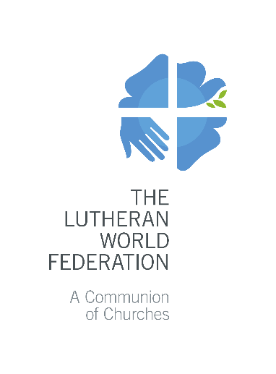
The Lutheran World Federation
P.O. Box 2100
CH-1211 Geneva 2
Switzerland
DMDprojects@lutheranworld.org

Annex 1 - Church Profile

- Basic information
Name of church:

Country:
Number of church members:
 | Total |  | Female |  | Male
Number of:
 | Synods |  | Parishes |  | Congregations
Number of pastors:
 | Total |  | Female |  | Male

- Historical Background

How was the church started and by whom?

What have been the major developments/changes/transitions over the years?
- Present Situation

What is the current structure of the church?

How are church leadership and governance processes organized?

How are women, men and youth involved in the life and leadership of the church?

How does the church promote gender equality and participation of youth?
Does the church have a Gender Policy? |  | Yes |  | No
Does the church have a Code of Conduct? |  | Yes |  | No
- Political and Socio-Economic Context

Provide an analysis of the current social, political and economic situation in the country, its impact on the life and work of the church.
- Main Challenges, Priorities and Activities
Does the church have a strategic plan? |  | Yes | No

What are currently the main challenges and priorities the church is faced with?
Which activities does the church carry out to fulfill these priorities and overcome these challenges?

Partnership and Relationships

Provide an overview of the church’s bilateral partners in mission and development.

Enumerate the church’s relationships with ecumenical and inter-faith partners. Indicate areas of partnership and any other ecumenical initiatives undertaken or with whom the church is in partnership.
- Capacity self-assessment
Please list the capacity needs/gaps in your church (if any), specifically in relation to project work, and explain the way these could be addressed.
- Ongoing Projects with LWF/DMD and New Requests
To be completed by LWF/DMD

