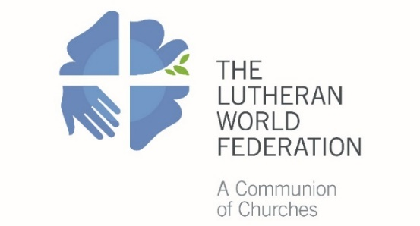
The Lutheran World Federation
Department for Mission and Development
Project Coordination and Monitoring desk
P.O. Box 2100
CH-1211 Geneva 2
Switzerland
DMDprojects@lutheranworld.org

Concept note for LWF Member Church Project

Please fill in only grey fields. Use the Tab button to move to the next field.
Only complete applications will be accepted. Max five pages (including Financial Plan)

1. Summary of Basic Information
Name of the Project:
Applying Church/Institution
Contact Person:
 | First name |  |  |  | Last name
 | Email |  |  |  | Telephone
Name of Endorsing Church:
Project Period: | From: |  |  | To:
Status: | Phase 1 (New) | Phase 2 |  |  |  | Phase 3

2. Amount Requested to the LWF

The minimum annual budget for a project is 5000€ and maximum 90,000€. Please see below the three budget categories and select the category according to the resources and capacity of the church:

5,000 up to 15,999 Euros (minimum application and reporting requirements)
16,000 up to 50,999 Euros (standard application reporting requirements)

51,000 up to 90,000 Euros (high application and reporting requirements)

3. Project Background and Rationale
Provide brief background on the project and its geographical location. Explain the problems the project is responding to, including the needs and opportunities to be addressed. How does the project link to the priorities of the member church? How does this new phase of the project link to the previous phase(s) (if any)?

4. Project Goal
What is the overall goal the project aims to achieve

5. Expected Results
Give concrete results that the project is expected to achieve during this project phase

6. Objectives of the Project and Main Activities
Describe the objectives of the project (max 3) and the main activities for each (max 5 per objective). Be SMART (Specific, Measurable, Achievable, Realistic and Timebound).
Objective 1: | Activities:
Activity 1
Activity 2
Activity 3
Activity 4
Activity 5

Objective 2: | Activities:
Activity 1
Activity 2
Activity 3
Activity 4
Activity 5

Objective 3: | Activities:
Activity 1
Activity 2
Activity 3
Activity 4
Activity 5

7. Target Group
Describe the target group/participants. Be specific, provide numbers and indicate the gender of potential participants. How have you involved the target group in the planning of the project? How do you plan to involve them in its implementation and management?

8. Gender-analysis and Youth Participation
What are the roles and responsibilities of women and men in the project? What are the different approaches needed to produce outcomes that are equitable? How will the participation of youth be ensured at all levels of the project?

9. Organizational Capacities
Who will be responsible for the implementation and monitoring of the project? What expertise, experience and competencies will those responsible have to implement this kind of work? What other programs / projects are under the responsibility of those running this project? Will you need to engage or acquire additional capacities? Describe the financial management systems in place, including the budget those responsible will have.

10. Sustainability
How will you ensure continuity of the work after support from the LWF has ended? What are your exit strategies

11. Comments
You can use this space to provide any other relevant information to support your application

12. Financial Plan (in local currency)
Total income needs to correspond to total expenditures
 | Yr. 1 | Yr. 2 | Yr. 3
1. Program/project Costs
  - Objective 1
  - Objective 2
  - Objective 3
1.4.
2. Administrative costs
2.1.
2.2.
2.3.
3. Capital Costs
3.1.
3.2.
3.3.
Total
Grants and Own Income
1. Own (specify)
2. Grants (specify)
3. Amount requested from the LWF
Total

