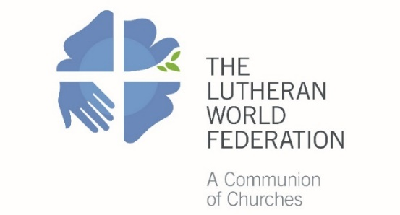
The Lutheran World Federation
Department for Mission and Development
Diakonia and Development Desk
P.O. Box 2100
CH-1211 Geneva 2
Switzerland
scholarships@lutheranworld.org

Human Resource Capacity Profile of Endorsing Church
Human and Institutional Capacity Development (HICD) for LWF Member Churches
Please fill in all relevant information and submit the completed form together with up to five applications to LWF/DMD on or before 1 October.

1. Basic Information

Name of Endorsing Church:

Number of Church Members:
 | Total |  | Female |  | Male
Number of:
 | Synods |  | Parishes |  | Congregations
Number of full-time Pastors:
 | Total |  | Female |  | Male

Qualifications of full-time Pastors:
Qualification | Total number | Female | Male
Certificate
Diploma
Bachelor Degree
Master Degree
Doctoral Degree
Qualifications of Leadership Staff:
Qualification | Total number | Female | Male
Certificate
Diploma
Bachelor Degree
Master Degree
Doctoral Degree

2. Institutions and Projects of the Church
Institutions | How many? | Total staff | Female staff |  | Male staff
Bible School
Seminary
Theological College
Primary School
Secondary School
College/University
Health Stations/Clinics
Hospitals
Diakonia Institution
Please indicate the type/name of the church’s diakonia institution/s:

Projects (Please indicate the type/name of the church’s project/s) | How many? | Total staff | Female staff |  | Male staff

Qualifications of theological training staff:
Qualification | Total number | Female | Male
Bachelor Degree
Master Degree
Doctoral Degree
Qualifications of education teaching staff:
Qualification | Total number | Female | Male
Certificate
Diploma
Bachelor Degree
Master Degree
Doctoral Degree
Qualifications of health institution staff:
Qualification | Total number | Female | Male
Certificate
Diploma
Bachelor Degree
Master Degree
Doctoral Degree
Qualifications of project staff:
Qualification | Total number | Female | Male
Certificate
Diploma
Bachelor Degree
Master Degree
Doctoral Degree

3. Human and Institutional Capacity Development (HICD)
  - Does the church have a long term plan for human resources development and/or capacity development?

YES | NO
If yes, please indicate: |  |  | Years the long-term plan covers:
 |  |  | Name of decision-making body of the church:
 |  |  | Date of approval of the  long-term plan: |  | / /
 |  |  |  |  | Day/Month/Year
  - How does the church mobilize resources for implementing the long-term plan? Please indicate the sources in percentages:
From its parishes and congregations: |  |  |  | From the LWF: |  | From other partners
% |  |  |  | % |  | %
  - In case the church does not have a long-term plan for human resources development and/or capacity development yet, how did it come up with the current application for training support?
  - Does the church have a Human Resources Development and/or Capacity Development Committee/Board?
YES | NO
If yes, please indicate: |  |  | Number of Committee/Board members:
Educational background and diversities of the Committee/Board members in numbers:
Education | Total number | Female | Male | Youth
Leadership
Management
Theology
Development
Other:
Other:
Other:
  - Does the church have a policy or guideline for human resources development and/or capacity development?
YES | NO
If yes, please indicate: |  |  | Date of approval: | / /
 |  |  |  | Day/Month/Year
 |  |  | For how long is the policy valid? | Until
 |  |  | Name of the approving board/committee of the church:
  - In case the church does not have a policy or guideline for human resources and/or capacity development yet, how does it regulate its education/training plans and priorities?
  - Which areas or types of human resources development and/or capacity development would the church consider as its strategic need or critical requirement for its holistic ministry? Please indicate main areas with concrete examples. An additional sheet may be used if necessary.
  - Name and Position of the Church Official Signing on Behalf of the Church:
Name |  | Position
Place, Date |  | Signature and Official Stamp

